RINGS-A000-EUR-Italy-Rome- Legio IV Macedonica

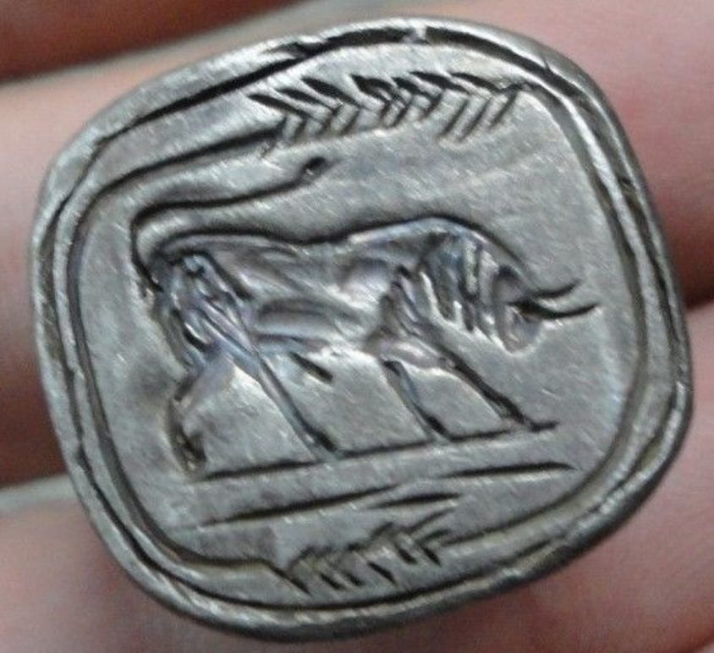

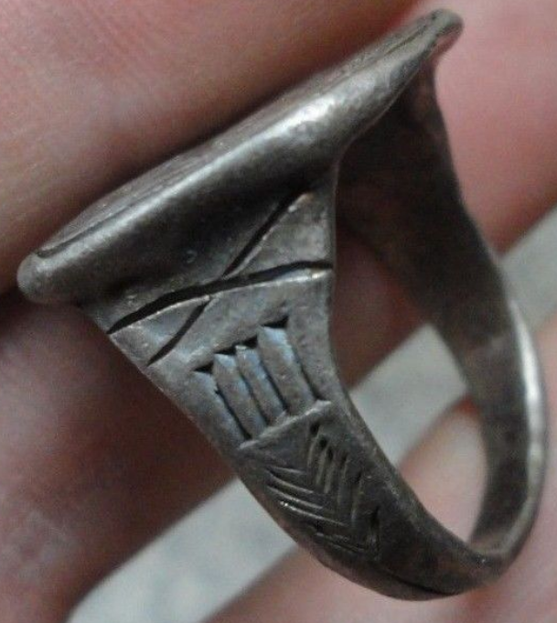 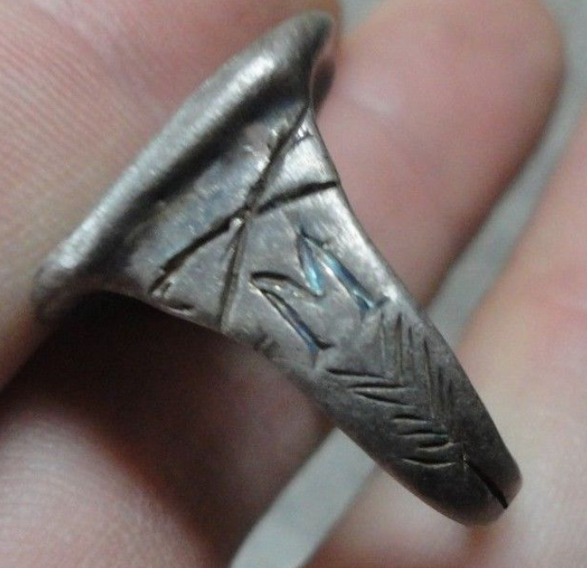 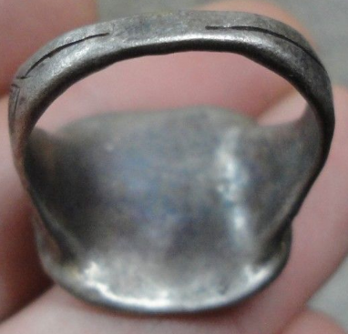

Legio IV Macedonica

Legio quarta Macedonica ("Macedonian Fourth Legion"), **was a legion of the Imperial Roman army founded in 48 BC by Gaius Julius Caesar (dictator of Rome 49-44 BC) with Italian legionaries. The legion was disbanded in AD 70 by Emperor Vespasian. The legion symbols were a bull (as with all of Caesar's legions) and a capricorn.**

INSCRIBED - BULL - Roman legionary combat symbol/emblem on the Legion " M - IIII "

EXTREMELY RARE **Roman SENATORIAL LEGIONARY SILVER ring.**

SOLID SILVER - Wearable <> 12.30 grams <>

**<> 21.30mm. = 0.85" Inner diameter <>**